Task #4 Final Research Paper:
A Socio-Feminist Approach to Emily Mary Osborn’s Nameless and Friendless

Olivia Tayler Sims
ART 497: Art History Methods
Dr. Mary Springer
March 11, 2020
Osborn is one of many notable female artists from Victorian England who was able to make a name for herself in the male-dominated art culture of the time. Osborn spent her early life in Kent and Essex until her family moved to London in 1842. Born as the daughter of a clergyman, Osborn was able to afford training in London to be a genre painter. Osborn chiefly produced genre paintings depicting women and children, which was typical subject matter for women to paint in this time, but Osborn is significant because she encoded the problems women faced in Victorian England in in these types of paintings. She also became an active participant in women’s rights in which she was a member of the Society of Female artists as well as having close connections with feminist (and artist) Barbara Bodichon’s Langham Place circle.
This paper will specifically analyze her work, Nameless and Friendless “The rich man’s wealth is his strong city, etc.” - Proverbs, x, 15 (1857). In this genre painting, Osborn depicts a young female artist with her gaze cast downwards, twirling a string in her hand in an art dealer’s shop waiting for the dealer’s decision of whether he will purchase her work. Except for a woman walking out the door, the young artist is surrounded by males all who seem interested in her presence, possibly the reason for her apparent discomfort.
There were many societal and cultural shifts taking place in this time in Victorian England, especially regarding the roles and rights of women. These shifts, also known as the first wave of feminism, initially confronted women’s right to vote, but also helped rise initial concerns for women entering the professional sphere of work or society. In this paper, I will take a socio-feminist approach by arguing that Osborn’s Nameless and Friendless reflects her emerging role as an active feminist as well as expanding the dialogue of the painting’s broader reflections on the struggles of not only female artists, but also women entering the professional sphere of work in Victorian England. This will be proven through a discussion of the societal expectations of female artists of this time; an evaluation of Osborn’s work prior to this painting with a discussion of consumers, patrons, and intended viewership; and the feminist influences that affected her shift in thought/painting.
Literature Review
Feminists art history writers Pamela G. Nunn, Deborah Cherry, and Linda Nochlin all reference Obsorn’s Nameless and Friendless as part of their discussion of the socio-cultural realm of Victorian female artists. Pamela Nunn discusses the Victorian trends and tropes found in Osborn’s paintings revealing her investment in the typical sentiments of mainstream art as well as the concerns and values addressing women in Victorian society. She also examines the subject of woman artists primarily participating in literary painting in relation to the socio-cultural expectations placed on middle and upper-class women in Victorian England. Cherry Deborah directly references Osborn’s Nameless and Friendless in her discussion of Victorian female artists and the ways in which they pushed against the societal boundaries placed on them. Linda Nochlin discusses Osborn’s Nameless and Friendless as a reflection of the power struggles women faced in Victorian society. What these historians do not address is the apparent shift taking place in Osborn’s thought and painting as seen through her painting Nameless and Friendless, this paper will address the points my by these historians, but also expand their dialogue into proving this shift.
In addition to the feminist art history writings and in support of arguing her notable shift, this paper will reference contemporary reviews and critiques of women artist and Osborn in particular, revealing the oppressive society in which women struggled to work in. It will also reference the works of Barbara Leigh Smith (Bodichon), of whom Emily Mary Osborn was closely associated with and influenced by, which helps reveal Osborn’s initial shift into her active participation in feminist thought and art. Her book entitled A Brief Summary, in Plain Language, of the Most Important Laws Concerning Women; Together with a Few Observations Thereon reveals the oppressive and unjust laws placed on women of that time which led her to write the book Women and Work as a call for reform regarding women’s rights in the workforce. She also founded the English Women’s Journal aiming to support females in Victorian society and is where many of her petitions in favor of women’s rights (of which Emily Mary Osborn participated in) can be found.
Osborn’s Early Work
Before we discuss the feminist influences, we must first have an evaluation of Osborn’s work prior to Nameless and Friendless. We can clearly see in works like ‘Home Thoughts’ (c.1856), ‘Pickles and Preserves,’ (c.1854) and ‘My Cottage Door’(c.1855) (there is not an extant image of the last two paintings), that she was participating in the expected and socially acceptable mode of painting for female artists of the time. A brief discussion of the societal values and roles placed on women in Victorian England help better to understand the contextual aspects of Osborn’s painting. Most women’s social status, whether upper or middle-class, entailed the reception of fiction, poetry, essays, diaries, and letters during their leisurely hours, in which society did not expect them to be learned in the professional or academic sense. Thus, it can be inferred that women were not expected (by the dominant patriarchal societal structure) to want to enter the professional sphere of work which would require further knowledge by gaining an academic or experiential education at a reputable institution, and most times would not be allowed or could not afford to gain such an education. This means that regarding female painters of the time, they were expected to paint only a variety of subjects, as the patriarchal society would dictate, such as literary scenes of which would expected to have an air of pretty, picturesque, pleasantness to its subject matter that would most likely have a morally uplifting tone. If they strayed from this expectation, they were generally scrutinized or chastised for “going out of their expected range.” Osborn would be trained in such a manner, in which she gained her painting education at Dickinson’s and Leigh’s Academies, where they most certainly enforced these societal ideals, as they were training primarily women artists.
Shifting away from her earlier works, what is particularly interesting about these paintings is the restraint seen as compared to Nameless and Friendless and those paintings to follow. These paintings mentioned above are simple scenes depicting socially accepted modes of subject matter, such as still life, or a domestic scene showing moralizing values of women, children, and mothers. Even the titles of her previous painting have a subdued, simplified nature. Nameless and Friendless, however, goes deeper; it reveals the economic injustice and morally compromised hypocrisy placed on women by the dominant patriarchy of the time. It is apparent that Osborn had a deeper meaning behind this work even by just looking at her title. Her title included the Bible verse Proverbs 10:15, in which analyzing the entire verse will find that it is about wealth disparity and how the rich are safely protected and backed by their wealth whereas the poor is always put at a disadvantage because they do not have the protection of wealth. In this case, she applied this very statement to the struggles of female artists of this time, especially the poor or working-class women striving to make a name for themselves in the male-dominated professional world. It is clear to see that she was particularly cautious in the beginning of her career with her subject matter so that she could establish her name in the artworld without critique or offense.
Early and Notable Patrons: Access into the Female Art Network
In addition to the subject matter Osborn initially started painting, it is important to evaluate her patrons in her early career and how they affected this shift. From the beginning, her work was purchased by men praising her paintings’, “…unpretending character,” and those who wished to encourage her further. This can reveal reasoning as to why she initially painted with such reverence to the socially acceptable ways for females to paint in Victorian England. She did so because she was trying to make a name for herself in the male dominated artworld. These initial purchases made by men and exhibitions at the Royal Academy led to her gaining commissions and eventually catching the attention of one of the most powerful females in Victorian society: Queen Victoria.
In 1855, the Queen purchased her painting exhibited at the Royal Academy ‘My Cottage Door.’ Although many historians note this significant patron in relation to Osborn’s oeuvre, they have not recognized the impact it had made on her. This purchase was made right before she created Nameless and Friendless, in which could have instigated a new way of thought for Osborn. The idea that she has made such a powerful connection in the artworld shows that now her intended audience is not just the oppressive dominant patriarchy only wishing to buy socially “acceptable” paintings from females, but now an audience that can change or influence these oppressive ideals through their power over society. Most significantly, and as historian Hilary Fraser notes in her article “Women and Fiction,” this new patron revealed the, “…importance of female networks in enabling women to become artists,” in which she addresses this problem as shown in her next work: Nameless and Friendless. Now Osborn has access into this female network and this access helped kickstart her proto-feminist thoughts and shift away from the typical socially acceptable mode of painting for female artists. The painting Nameless and Friendless only appears to be a simple domestic-scene painting, but through this access to female power, she has imbued it with a propagandistic nature focusing on the increasingly real issue of women’s rights in hopes to once again capture the attention of the Queen, who could address this issue.
A Closer Look at Nameless and Friendless
A formal analysis of Nameless and Friendless is now needed in order to fully understand how her subject matter highlights these injustices. As stated earlier, Nameless and Friendless is a genre painting depicting a young female artist trying to sell her work to a seemingly critical dealer. Her face is forlorn, in which you could compare this character to another similar looking female she painted in her Home Thoughts painting. The female in these two paintings appear the same, in which they are wearing very similar outfits; however, the female in Home Thoughts looks much cheerier than the one she depicted in Nameless and Friendless. The reason for why the young girl in her later painting seems in distress is for the fact that it appears she has very little chance of making money or establishing a name for herself in the professional art scene due to the look from the dealer. Also, her apparent discomfort could be from the fact that the dealer has not given her the common courtesy of a seat while he evaluates her work. This shows the lack of respect found towards women when entering the male dominated professional world of art. Another formal aspect of her painting that provides insight into her deeper meaning on the social and economic injustices, in which many historians have yet to fully analyze, is the inclusion of what appears to be a much wealthier woman leaving the shop. The fact that Osborn has included this (probably) aristocratic woman leaving the shop is to show that there is a market for female artists out there, but only to the privileged few who are able to afford training (and most likely only the ones who follow the socially acceptable modes of painting for females of this time) or who can afford to be patrons. Osborn is showing how specifically the underprivileged women in Victorian society are put at a disadvantage (as her title suggests) and she is trying to highlight this injustice by directly comparing the two types of women in this society. Furthermore, Osborn included these powerful gazes from all the surrounding men to highlight their overriding dominance in the art world and show how scrutinous and critical they were of female artists. On the left, you can see a pair of men looking up from their newspaper to gawk at the poor female as they most likely compare the work they are seeing in the newspaper (most likely created by a man) with her work. There is also a man at the top right on a ladder that is also interested in the female’s presence and work. The only male in the room that is not placing their critical gaze on the woman is the younger boy looking intently at the dealer, possibly in hopes of reassuring the dealer that she is a good painter. All these formal details help prove her notable feminist shift by them all highlight the economic and social justices placed on women (specifically working-class or poor women) in Victorian England.
Feminist Influences
This shift in Osborn towards support of women’s right and emerging feminism found in Nameless and Friendless can further be explained through the feminist influences surrounding the time of creation and exhibition of the painting in Victorian society. In previous studies of Osborn, it has already been established that she had a connection with prominent feminist Barbra Bodichon and actively participated in petitions in favor of women’s rights. However, in addition to not recognizing Osborn’s shift in thought found in Nameless and Friendless, they also fail to recognize that around the same time Osborn was painting and exhibiting this work, Bodichon was writing significant and influential essays/treatises on women’s rights that most certainly help impact Osborn’s thoughts; thus her writings helped create that shift in her painting’s subject matter and intended meaning. For instance, in 1854 Barbara Bodichon published A Brief Summary, in Plain Language, of the Most Important Laws Concerning Women; Together with a Few Observations Thereon, in which she initially addresses that, “women, more than any other member of the community, suffer from over-legislation.” This would have been made public around the same time that Osborn would have been painting Nameless and Friendless. Therefore, it can be inferred that, with one of her most recent paintings just being sold to the most powerful female in society, the Queen, and her seeing this writing done by her close associate, these influences can be linked to her new way of painting found in Nameless and Friendless. Osborn has now been able to recognize these injustices placed on women in the professional sphere and now that she has an audience that can actually enact change, she is able to made a deeper statement on the economic and societal oppression place on women encoded in English genre painting.
It is also interesting to note that after Osborn’s Nameless and Friendless was painted and exhibited, Bodichon published Women and Work, in which was her call for more rights for women regarding the professional sphere of work or society. Bodichon claims that women want work, according to the 60,000 signatures on her petition, and she states that women must and should be trained in the professional sense. This is particularly relevant to Osborn’s painting in which she, too, is calling for better rights and opportunities for females entering the professional sphere, especially female artists. It is no coincidence that this painting correlates with Bodichon’s publication; they both were participating in these feminist actions alongside each other, just in different mediums. There is also evidence of Osborn signing this petition, in which is clear evidence that Osborn participated in this feminist shift with Bodichon. This petition addressed the Royal Academy, in which they called for female admissions into the school so that they could have the same privileges men receive in their artistic training. Although she signed this after Nameless and Friendless was created, there is a clear progression in Osborn’s thought surrounding the painting’s creation. She first was influenced by Bodichon’s initial observations on the unjust laws concerning women; she then exhibited her work in correlation with Bodichon’s publication calling for the rights of women in the professional sense; and finally, she acts on her influences and on the subject matter of her painting- she petitions for the rights of underprivileged female artists, like the one she depicted in her painting. These feminist influences are the most crucial aspect that helped inform her thought in painting in relation to Nameless and Friendless.
Conclusion
Overall, Nameless and Friendless represents a marked shift in Osborn towards her notable feminist attitudes of the later 19th century. This is an important expansion on the art historical discourse about Osborn in relation to her highlighting the plights of women in Victorian England. This observation could help open new discourse in relation to not only Osborn’s genre paintings but could open the door to a new way of seeing seemingly “normal” genre paintings by other female artists of the time. Could it be a possibility that there were more women participating in this feminist shift through their painting than we thought? Further art historical research with reverence to this idea would be needed to find out.

Bibliography

Elderton, Louisa, Rebecca Morrill, and Karen Wright. Great Women Artists. New York City: Phaidon Press, 2019.
Cherry, Deborah. Beyond the Frame: Feminism and Visual Culture, Britain 1850-1900. London: Routledge, 2000.
Dafforne, James. “British Artists, their Style and Character, no. lxxv, Emily Mary Osborn.” Art Journal 26 (1864): 261-263.
Fraser, Hilary. “Women and the Art of Fiction.” The Yearbook of English Studies 40, no. ½ (2010): 61-82.
Helland, Janice. “The Self as Fin-de-Siécle Woman.” Woman’s Art Journal 14, no. 1 (1993): 15-22.
Kahle, Antje. First Wave of Feminism in Politics and Literature. Norderstedt: GRIN Verlag, 2005.
Losano, Antonia. Woman Painter in Victorian Literature. Columbus: Ohio State University Press, 2008.
Meskimmon, Marsha. Women Making Art: History, Subjectivity, Aesthetics. New York: Routledge, 2003.
Nochlin, Linda. Women, Art, and Power and Other Essays. New York: Routledge, 2018.
Nunn, Pamela G. “Between Strong-Mindedness and Sentimentality: Women’s Literary Painting.” Victorian Poetry 33, no. ¾ (1995): 425-447.
Nunn, Pamela G. “Gone but Not Forgotten.” Australasian Journal of Victorian Studies 21, no. 1 (2016): 58-71.
Shefer, Elaine. “Woman’s Mission.” Woman’s Art Journal 7, no. 1 (1986): 8-12.
Smith, Barbara L. A Brief Summary, in Plain Language, of the Most Important Laws Concerning Women; Together with a Few Observations Thereon. London: W. Cloves and Sons, 1854.
Smith, Barbara L. Women and Work. London: Bosworth and Harrison, 1857.
“XLV.- Passing Events,” The English Women’s Journal 3, (June 1859): 1-430.
Zakreski, Patricia. Representing Female Artistic Labor, 1848-1890: Refining Work for the Middle-Class Woman. Burlington: Ashgate Publishing Company, 2006.
Illustrations
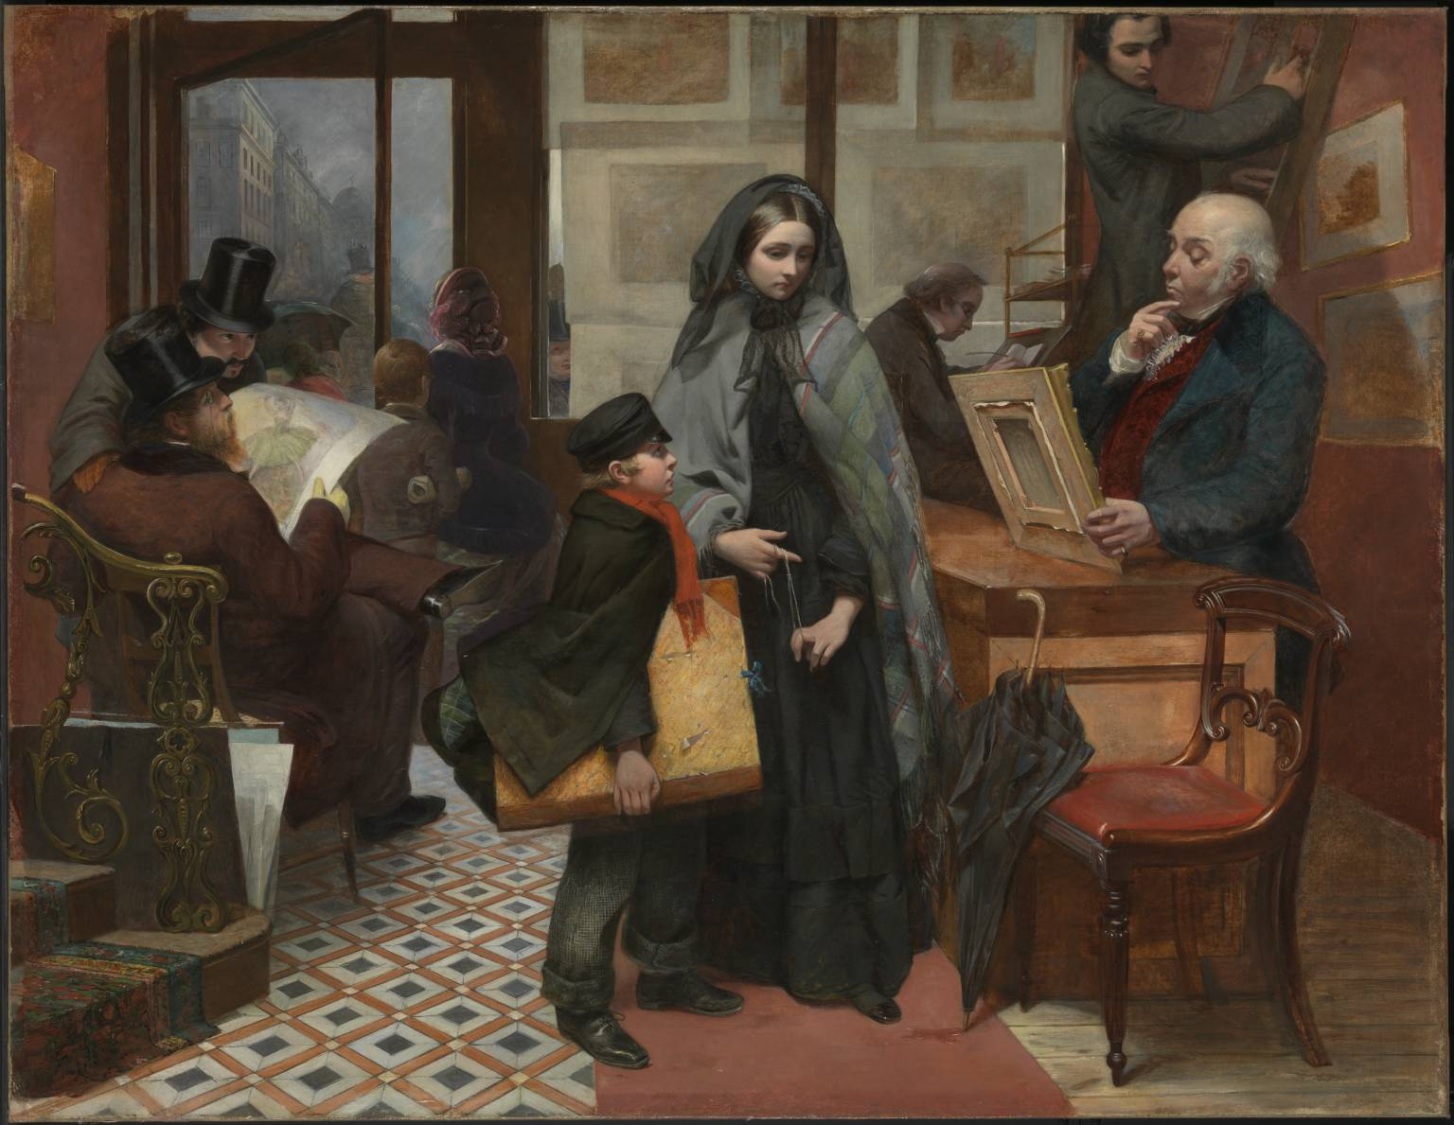
Figure 1. Emily Mary Osborn, Nameless and Friendless “The rich man’s wealth is his strong city, etc.” - Proverbs, x, 15, 1857. Oil paint on canvas. Tate Museum Collection.

Linda Nochlin, Women, Art, and Power and Other Essays (New York: Harper and Row Publishers, 1988), 88.
Marsha Meskimmon, Women Making Art: History, Subjectivity, Aesthetics (New York: Routledge, 2003), 80.
Antje Kahle, First Wave of Feminism in Politics and Literature (Norderstedt: GRIN Verlag, 2005), 3.
Pamela G. Nunn, “Gone but Not Forgotten,” Australasian Journal of Victorian Studies 21, no. 1 (2016): 69.
Cherry, Deborah, Beyond the Frame: Feminism and Visual Culture, Britain 1850-1900 (London: Routledge, 2000), 37.
Linda Nochlin, Women, Art, and Power and Other Essays (New York: Routledge, 2018), 15-17.
Pamela Nunn, “Between Strong-Mindedness and Sentimentality: Women’s Literary Painting,” Victorian Poetry 33, no. ¾ (1995): 425.
Janice Helland, “The Self as Fin-de-Siécle Woman,” Woman’s Art Journal 14, no. 1 (1993): 15.
James Dafforne, “British Artists, their Style and Character, no. lxxv, Emily Mary Osborn,” Art Journal 26 (1864): 261.
Louisa Elderton, Rebecca Morrill, and Karen Wright, Great Women Artists (New York City: Phaidon Press, 2019), 309.
Many female artists of the time would be left with strong disapproval if they attempted at any genre that could be used to create a deeper meaning rather than simply replicating the appearance. This supposed lack of originality expected in female artists’ work also became a feature of cultural commentary early in the “woman question” of the time. Pamela Nunn, “Between Strong-Mindedness and Sentimentality: Women’s Literary Painting,” Victorian Poetry 33, no. ¾ (1995): 428-434.
James Dafforne, “British Artists, their Style and Character, no. lxxv, Emily Mary Osborn,” Art Journal 26 (1864): 261.
Fraser, Hilary, “Women and the Art of Fiction,” The Yearbook of English Studies 40, no. ½ (2010): 67.
Elaine Shefer notes how female artists of the time were beginning to realize the increasing issue of women’s rights and how they used domestic scene paintings as a propagandistic tool to help “curb this tide.” Elaine Shefer, “Woman’s Mission,” Woman’s Art Journal 7, no. 1 (1986): 11.
Patricia Zakreski, Representing Female Artistic Labor, 1848-1890: Refining Work for the Middle-Class Woman, (Burlington: Ashgate Publishing Company, 2006). 72.
Marsha Meskimmon, Women Making Art: History, Subjectivity, Aesthetics (New York: Routledge, 2003), 80.
Antonia Losano, Woman Painter in Victorian Literature, (Columbus: Ohio State University Press, 2008), 38-40.
Barbara L. Smith, A Brief Summary, in Plain Language, of the Most Important Laws Concerning Women; Together with a Few Observations Thereon, (London: W. Cloves and Sons, 1854), 13.
Barbara L. Smith, Women and Work, (London: Bosworth and Harrison, 1857), 19.
“XLV.- Passing Events,” The English Women’s Journal 3, (June 1859): 287.

